
Year 11 ATAR Chemistry
Investigation – Validation Test
Decomposition of hydrogen peroxide

NAME: ________________________ TEACHER: ________________________
MARKS: _____ / 14
Answer each question in the space provided.
- Using a diagram, show the effect of a catalyst on the rate of a typical endothermic chemical reaction.
(3 marks)

- Explain how catalysts can be used to increase the rate of a chemical reaction. (2 marks)

- Consider the following data showing an experiment where another catalyst (Catalyst X) was added to a 10 mL solution of hydrogen peroxide and the evolution of oxygen gas measured over a period of 40 seconds.
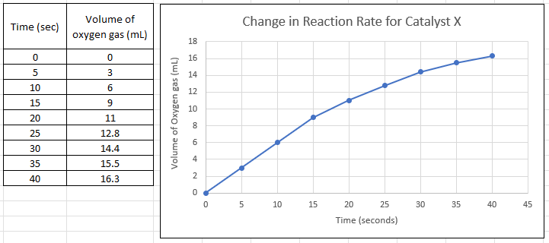
- From the graph, determine the reaction rate for the time period between 15 seconds and 30 seconds. (3 marks)

- Predict how long it would take for 10 mL of oxygen gas to be evolved. (1 mark)

- What are the issues involved with performing experiments where gas needs to be collected? What is an idea for mitigating these issues? (3 marks)

- This investigation looked into the application of catalysts in contact lenses. What are two other applications of how catalysts can be useful? (2 marks)

End of Validation Test

